Set up your SAW account:

1. Begin by navigating to the Secure Access Washington (SAW) website at [SecureAccess Washington.](https://secureaccess.wa.gov/myAccess/saw/select.do) Then click ‘Sign Up!’ in the upper right-hand corner.

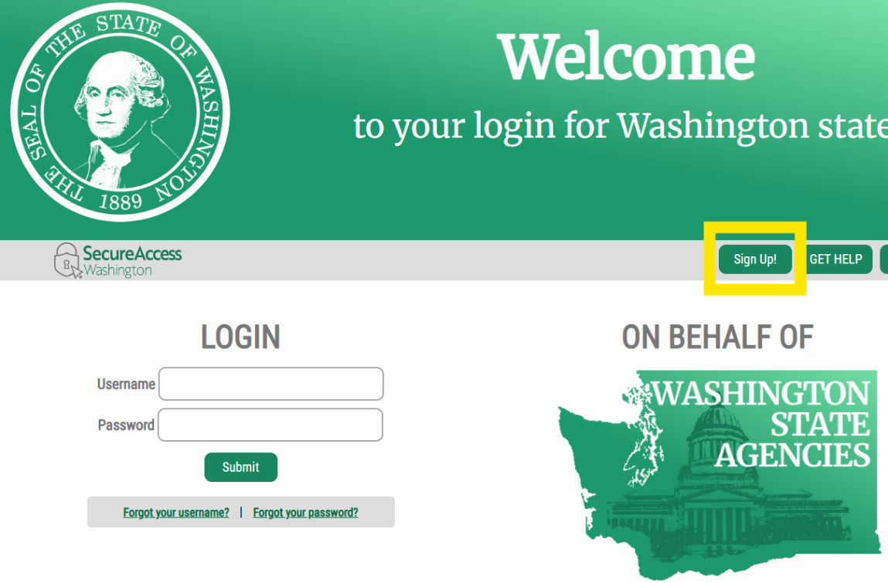

1. Complete the form.
   1. Begin by entering your first name, last name, and primary email address. *Please note that the primary email address that you input* ***must*** *match your email address on file with OCLA.*

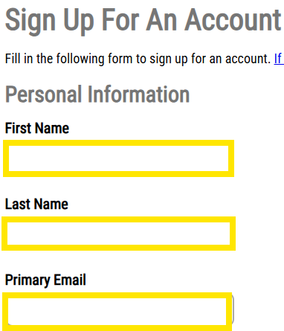

* 1. Next you may add an additional email address and phone number. This is optional and may assist in recovering your account.

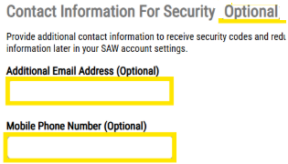

* 1. Finally, enter a username and password. *We recommend that you* ***use your primary email as your username****.*

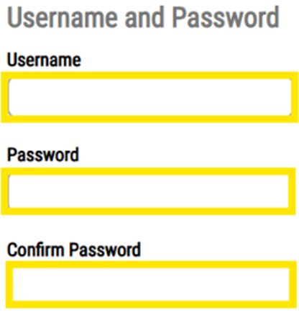d. Then click ‘Create My Account’

Picture 601884102, Picture

1. Once you click ‘Create my Account’, the following should pop up:

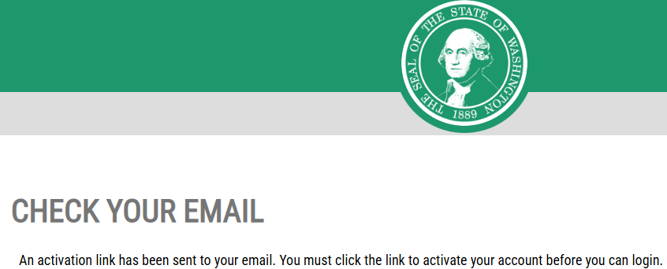

1. Login to the primary email that you used to create this account. Look for an email from [secureaccess@cts.wa.gov (see example below).](mailto:secureaccess@cts.wa.gov%20(see%20example%20below).) The email will contain an activation link.

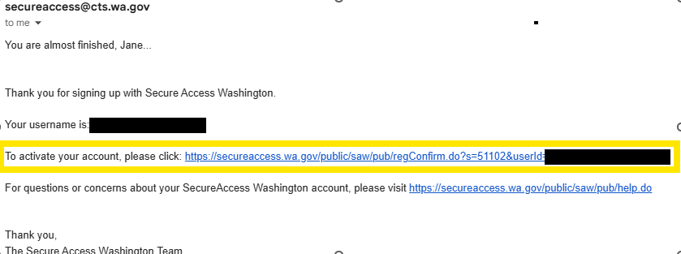

1. Click on the link to activate your account. It will take you to this screen. Click the ‘Login’ button.

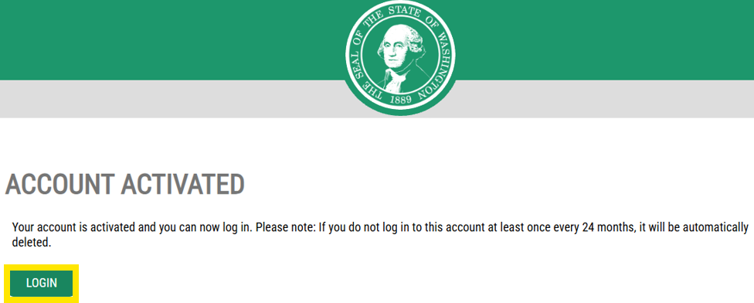

1. The screen below will pop up. Click on ‘Review My Profile’.

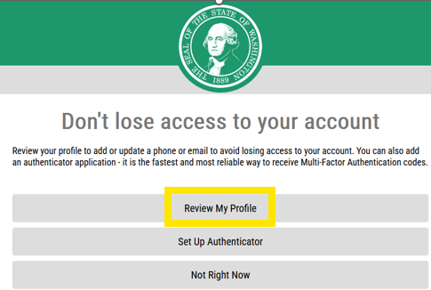

1. Click on the mail icon to have an authorization code sent to your email.

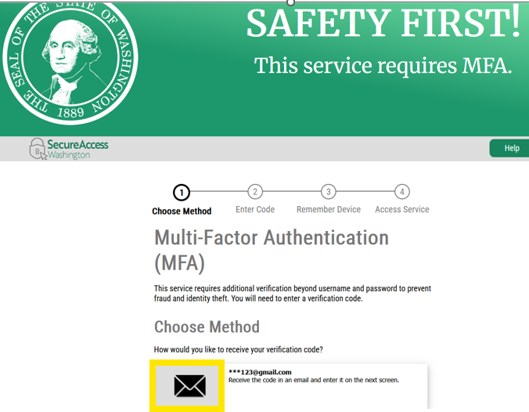

1. Check your email for the code. Once you have it, put it in the provided field and click ‘Submit’.

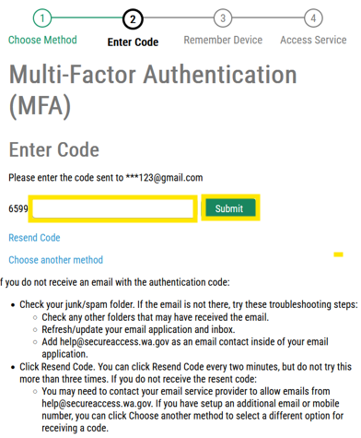

1. You will then go to the Manage Your Profile screen. Fill it out and click the ‘UPDATE’ button.

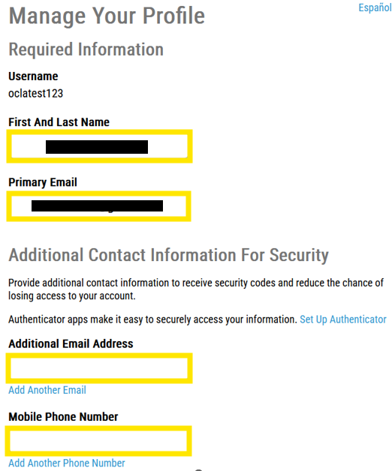

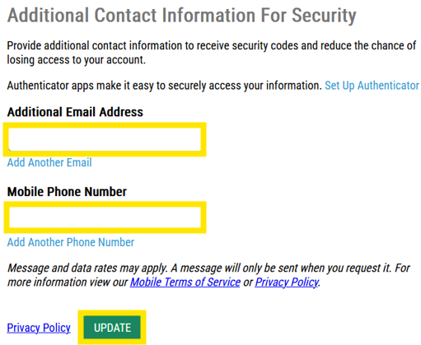

1. *A screen will pop up saying your update is complete. Hit the ‘Close’ button.*

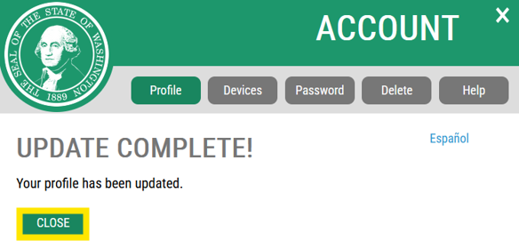

1. At this point, for access to work correctly, we recommend you close the entire browser windowand reopen the browser
2. Once the browser is reopened, navigate to [www.ocla.wa.gov](https://www.ocla.wa.gov/). Scroll to the bottom of the page and in the bottom right corner click on ‘Contractor Login’.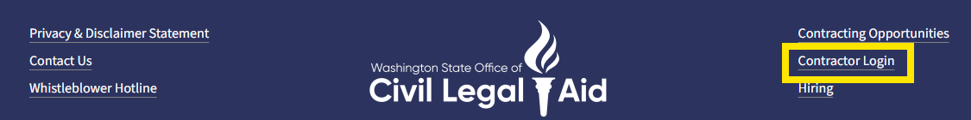
3. It will prompt you to enter your SAW login information.

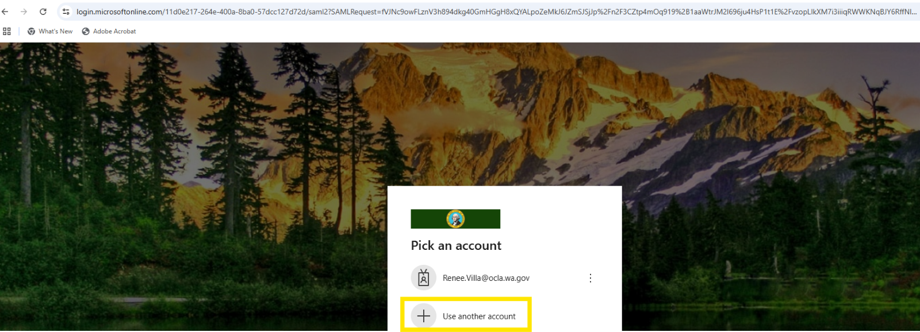

1. From the Contractor Login page, click on the OCLA program to which you are associated.